Evidence Gathering Document for SQA Level 8 Professional Developer Award.

This document is designed for you to present your screenshots and diagrams relevant to the PDA and to also give a short description of what you are showing to clarify understanding for the assessor.

Please fill in each point with screenshot or diagram and description of what you are showing.



Each point requires details that cover each element of the Assessment Criteria, along with a brief description of the kind of things you should be showing.

**Week 2**

| Unit | Ref | Evidence |  |
| --- | --- | --- | --- |
| I&T | I.T.5 | Demonstrate the use of an array in a program. Take screenshots of:  *An array in a program  *A function that uses the array  *The result of the function running | |
|  |  | **Description:** | |

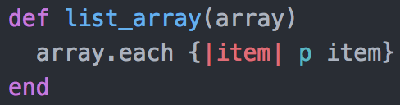

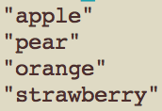

This is a simple function which takes an array, in this case fruits, and ‘puts’ out each item in turn.

| Unit | Ref | Evidence |  |
| --- | --- | --- | --- |
| I&T | I.T.6 | Demonstrate the use of a hash in a program. Take screenshots of:  *A hash in a program  *A function that uses the hash  *The result of the function running | |
|  |  | **Description:** | |

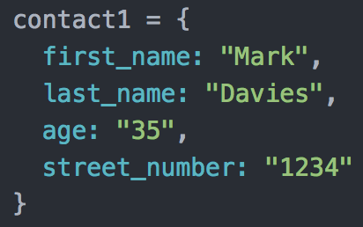

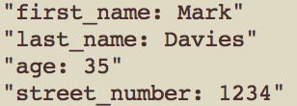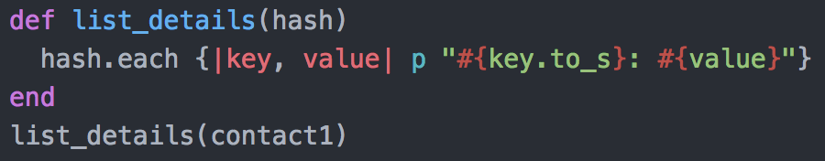

contact1 is a hash including someone’s personal details. The list_details function prints each field of the hash in a structured sentence.

**Week 3**

| Unit | Ref | Evidence |  |
| --- | --- | --- | --- |
| I&T | I.T.3 | Demonstrate searching data in a program. Take screenshots of:  *Function that searches data  *The result of the function running | |
|  |  | **Description:** | |

This demonstration uses SQL code. The first image shows the creation of a new database table called movies. The table is given fields, each of which have an expected data type. The second image shows some movies being inserted in to the table. The third image is the code which calls upon the table contents. It could be used elsewhere in the program in a function to return all of the elements from the table. The fourth and final image is of the code in the third image displayed in the terminal.

| Unit | Ref | Evidence |  |
| --- | --- | --- | --- |
| I&T | I.T.4 | Demonstrate sorting data in a program. Take screenshots of:  *Function that sorts data  *The result of the function running | |
|  |  | **Description:** | |

As with the previous task (I.T.3), this task shows a database table being created and populated in the first two images. The SQL query in the third image pulls out all the elements from that table, sorting them alphabetically by the title field.

**Week 5 and 6**

| Unit | Ref | Evidence |  |
| --- | --- | --- | --- |
| A&D | A.D.1 | A Use Case Diagram | |
|  |  | **Description:** | |

**Paste Screenshot here**

**Description here**

| Unit | Ref | Evidence |  |
| --- | --- | --- | --- |
| A&D | A.D.2 | A Class Diagram | |
|  |  | **Description:** | |

**Paste Screenshot here**

**Description here**

| Unit | Ref | Evidence |  |
| --- | --- | --- | --- |
| A&D | A.D.3 | An Object Diagram | |
|  |  | **Description:** | |

**Paste Screenshot here**

**Description here**

| Unit | Ref | Evidence |  |
| --- | --- | --- | --- |
| A&D | A.D.4 | An Activity Diagram | |
|  |  | **Description:** | |

**Paste Screenshot here**

**Description here**

| Unit | Ref | Evidence |  |
| --- | --- | --- | --- |
| A&D | A.D.6 | Produce an Implementations Constraints plan detailing the following factors:  *Hardware and software platforms  *Performance requirements  *Persistent storage and transactions  *Usability  *Budgets  *Time | |
|  |  | **Description:** | |

**Paste Screenshot here**

**Description here**

| Unit | Ref | Evidence |  |
| --- | --- | --- | --- |
| P | P.5 | User Site Map | |
|  |  | **Description:** | |

**Paste Screenshot here**

**Description here**

| Unit | Ref | Evidence |  |
| --- | --- | --- | --- |
| P | P.6 | 2 Wireframe Diagrams | |
|  |  | **Description:** | |

**Paste Screenshot here**

**Description here**

| Unit | Ref | Evidence |  |
| --- | --- | --- | --- |
| P | P.10 | Example of Pseudocode used for a method | |
|  |  | **Description:** | |

**Paste Screenshot here**

**Description here**

| Unit | Ref | Evidence |  |
| --- | --- | --- | --- |
| P | P.13 | Show user input being processed according to design requirements. Take a screenshot of:  * The user inputting something into your program  * The user input being saved or used in some way | |
|  |  | **Description:** | |

**Paste Screenshot here**

**Description here**

| Unit | Ref | Evidence |  |
| --- | --- | --- | --- |
| P | P.14 | Show an interaction with data persistence. Take a screenshot of:  * Data being inputted into your program  * Confirmation of the data being saved | |
|  |  | **Description:** | |

**Paste Screenshot here**

**Description here**

| Unit | Ref | Evidence |  |
| --- | --- | --- | --- |
| P | P.15 | Show the correct output of results and feedback to user. Take a screenshot of:  * The user requesting information or an action to be performed  * The user request being processed correctly and demonstrated in the program | |
|  |  | **Description:** | |

**Paste Screenshot here**

**Description here**

| Unit | Ref | Evidence |  |
| --- | --- | --- | --- |
| P | P.11 | Take a screenshot of one of your projects where you have worked alone and attach the Github link. | |
|  |  | **Description:** | |

**Paste Screenshot here**

**Description here**

| Unit | Ref | Evidence |  |
| --- | --- | --- | --- |
| P | P.12 | Take screenshots or photos of your planning and the different stages of development to show changes. | |
|  |  | **Description:** | |

**Paste Screenshot here**

**Description here**

**Week 7**

| Unit | Ref | Evidence |  |
| --- | --- | --- | --- |
| P | P.16 | Show an API being used within your program. Take a screenshot of:  * The code that uses or implements the API  * The API being used by the program whilst running | |
|  |  | **Description:** | |

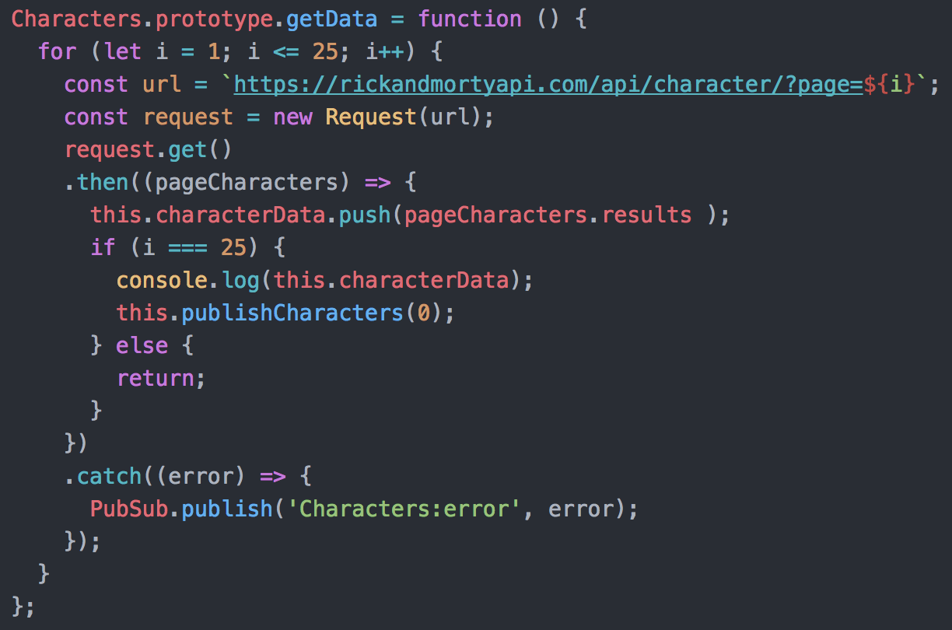

This first image shows a function (getData). It is responsible for making 25 requests to the Rick and Morty api, with the intention of returning 25 pages of character information. It creates a new request for each of the 25 urls and uses the get method, shown next:

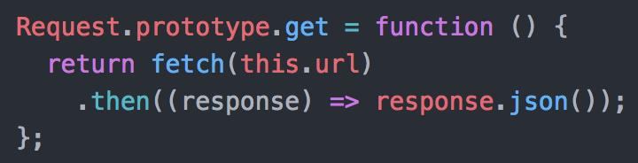

The get function uses fetch, targeting the url that was used to create it. The fetch request type defaults to ‘GET’. The response of the fetch is then sent back to the origin of the function.

When the response is returned to the getData function in the first image, the data is pushed to the characters model under the characterData field, along with the other pages.

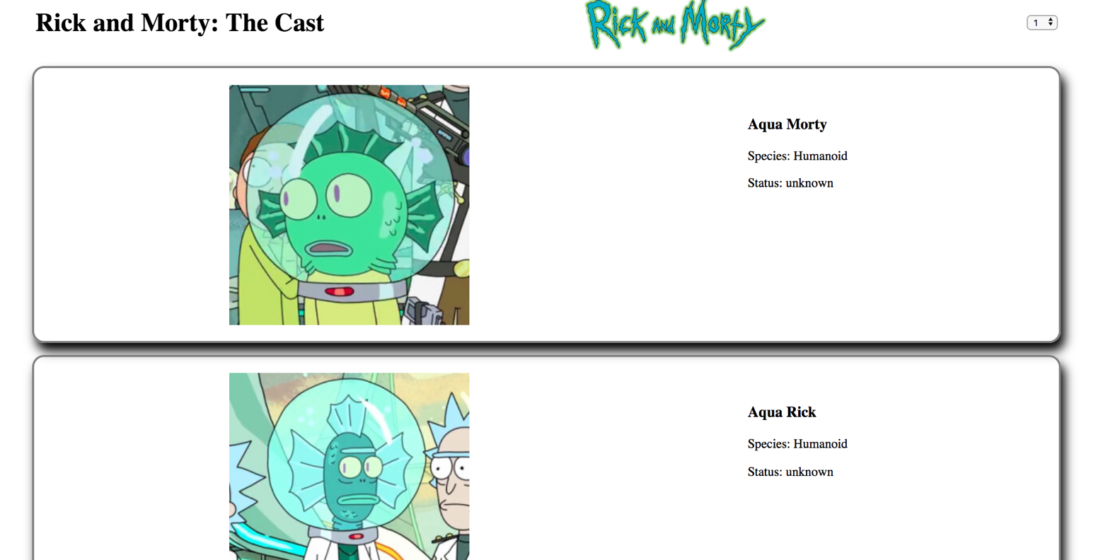Once all the data has been gathered, the first page of characters is published to the browser as shown below:

| Unit | Ref | Evidence |  |
| --- | --- | --- | --- |
| P | P.18 | Demonstrate testing in your program. Take screenshots of:  * Example of test code  * The test code failing to pass  * Example of the test code once errors have been corrected  * The test code passing | |
|  |  | **Description:** | |

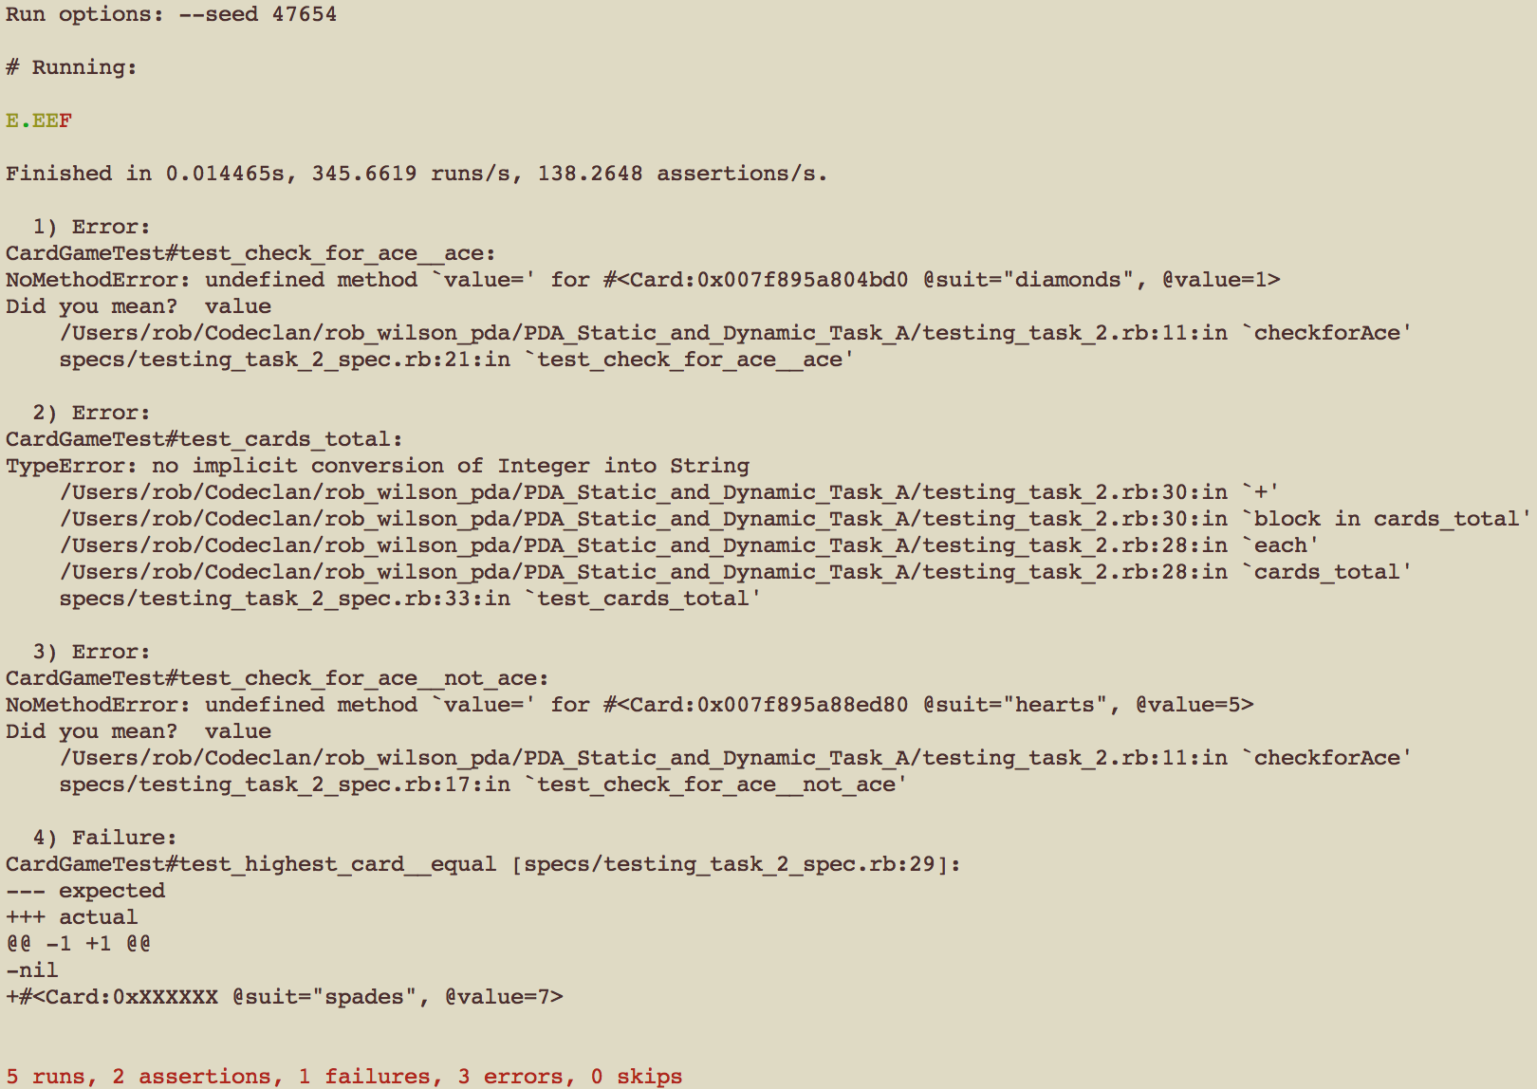

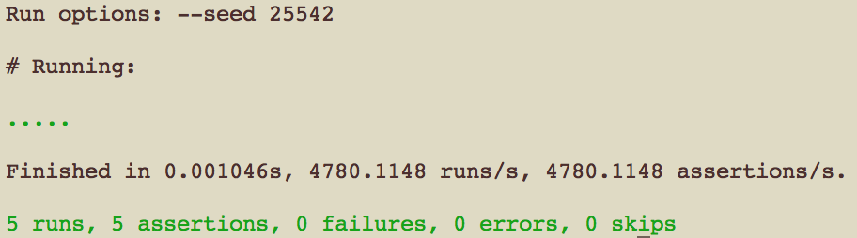

The first image shows the 5 tests running before the tested code has been fully corrected. The second, once it has been altered and refactored to pass the 5 comprehensive tests.

See the folder ‘PDA_Static_and_Dynamic_Task_A’ within this repository for both the test code and the tested code.

**Week 9**

| Unit | Ref | Evidence |  |
| --- | --- | --- | --- |
| P | P.1 | Take a screenshot of the contributor’s page on Github from your group project to show the team you worked with. | |
|  |  | **Description:** | |

**Paste Screenshot here**

**Description here**

| Unit | Ref | Evidence |  |
| --- | --- | --- | --- |
| P | P.2 | Take a screenshot of the project brief from your group project. | |
|  |  | **Description:** | |

**Paste Screenshot here**

**Description here**

| Unit | Ref | Evidence |  |
| --- | --- | --- | --- |
| P | P.3 | Provide a screenshot of the planning you completed during your group project, e.g. Trello MOSCOW board. | |
|  |  | **Description:** | |

**Paste Screenshot here**

**Description here**

| Unit | Ref | Evidence |  |
| --- | --- | --- | --- |
| P | P.4 | Write an acceptance criteria and test plan. | |
|  |  |  | |

**Paste Screenshot here**

**Description here**

| Unit | Ref | Evidence |  |
| --- | --- | --- | --- |
| P | P.7 | Produce two system interaction diagrams (sequence and/or collaboration diagrams). | |
|  |  | **Description:** | |

**Paste Screenshot here**

**Description here**

| Unit | Ref | Evidence |  |
| --- | --- | --- | --- |
| P | P.8 | Produce two object diagrams. | |
|  |  | **Description:** | |

**Paste Screenshot here**

**Description here**

| Unit | Ref | Evidence |  |
| --- | --- | --- | --- |
| P | P.17 | Produce a bug tracking report | |
|  |  | **Description:** | |

**Paste Screenshot here**

**Description here**

**Week 12**

| Unit | Ref | Evidence |  |
| --- | --- | --- | --- |
| I&T | I.T.7 | The use of Polymorphism in a program and what it is doing. | |
|  |  | **Description**: | |

**Paste Screenshot here**

**Description here**

| Unit | Ref | Evidence |  |
| --- | --- | --- | --- |
| A&D | A.D.5 | An Inheritance Diagram | |
|  |  | **Description:** | |

**Paste Screenshot here**

**Description here**

| Unit | Ref | Evidence |  |
| --- | --- | --- | --- |
| I&T | I.T.1 | The use of Encapsulation in a program and what it is doing. | |
|  |  | **Description:** | |

**Paste Screenshot here**

**Description here**

| Unit | Ref | Evidence |  |
| --- | --- | --- | --- |
| I&T | I.T.2 | Take a screenshot of the use of Inheritance in a program. Take screenshots of:  *A Class  *A Class that inherits from the previous class  *An Object in the inherited class  *A Method that uses the information inherited from another class. | |
|  |  | **Description:** | |

**Paste Screenshot here**

**Description here**

| Unit | Ref | Evidence |  |
| --- | --- | --- | --- |
| P | P.9 | Select two algorithms you have written (NOT the group project). Take a screenshot of each and write a short statement on why you have chosen to use those algorithms. | |
|  |  | **Description:** | |

**Paste Screenshot here**

**Description here**